**CHAPTER II**

**PROJECT ORGANIZATION**

**2.1 External Interfaces**

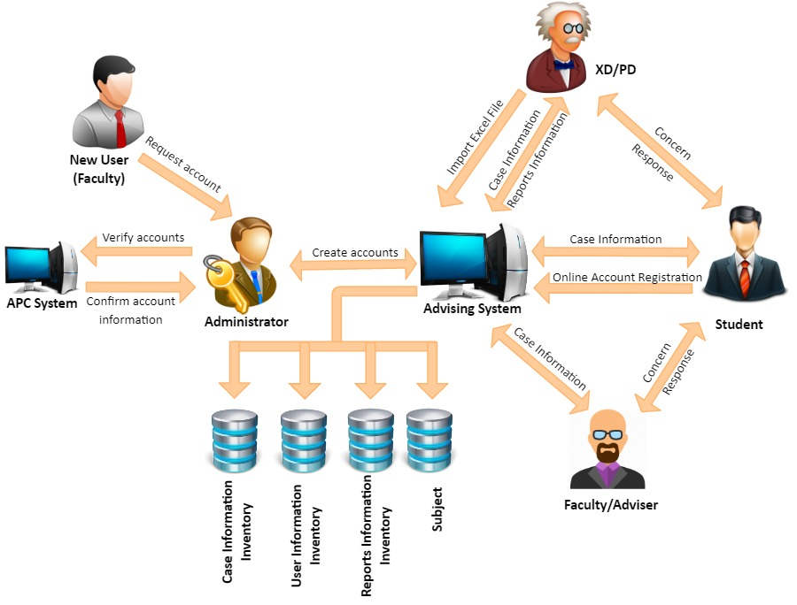

**Figure 2.1 External Interfaces**

Figure 2.1 shows the relationship of the entities with the system. When a new user needs to register, ne needs to go to the administrator. The administrator will look into the APC system to validate and verify the new user identify. If verified, the new user will proceed with the registration to create an online account. Once done, he is ready to login. ACAMS allows student - faculty interaction to be organized, focused, efficient, and effective. When a user has a concern, regardless of nature, he just needs to find a computer within the APC premises and go to ACAMS website. He just needs to create a case and once a case number is generated and saved, it will be available to the other user involved. Ultimately, the system is a means to support the faculty or student to deal with any interaction in the school, managing the interaction from the moment they’re captured through to their resolution.

**2.2 Internal Structure**

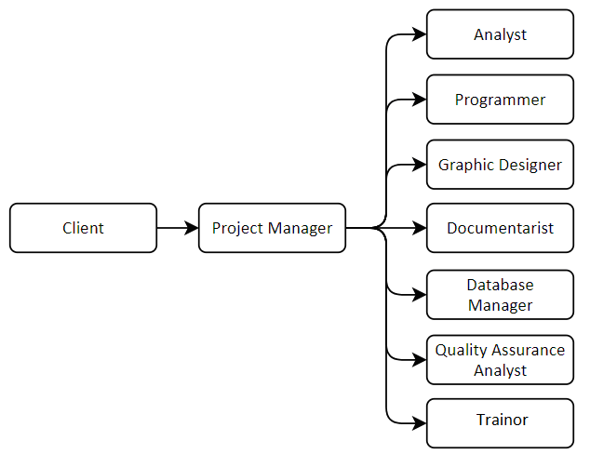

**Figure 2.2 Internal Structure**

Figure 2.2 shows the people involved in planning, assigning, analyzing, and developing the system proposed by the client in a hierarchical model. Each entity corresponds to the type of manpower as well as which phase they are included in the whole phase of the system development.

**2.1 Roles and Responsibilities**

**Table 2.1. Roles and Responsibilities**

|  |  |
| --- | --- |
| **Name of Position** | **Description of Task** |
| Client | The person who is knowledgeable about the system to be created. He serves as the source of information and verification with regard to the project itself. |
| Project Manager | He will manage, plan, monitor, assign task and ensure that the project is properly designed and created to fulfill all the requirements specified by the client. He is responsible for the its successful completion. |
| Analyst | He is responsible for ensuring that the requirements of the client is captured and documented correctly before a solution is developed and implemented for making the project more efficient and effective. |
| Programmer | The one who will develop the analyses and the design approved by the client in a system. |
| Graphic Designer | His role is styling and lay outing of pages with content, including text and images. He will focus on the design process relating to the front-end (client side) design of a website. |
| Database Manager | A specialist that models, designs and creates the databases and tables used by a software solution. This role combines Data Administrator (logical) and DBA (physical). |
| Quality Assurance Analyst | The one who will develop test plans, test cases and test scripts for projects, among other assigned duties. He is in charge of ensuring that the system contains no errors by analyzing development data. |
| Documentarist | The person creates and keeps a copy of all the requirements needed as a proposal for Software Engineering project. He oversees making the minutes of the meeting for every consultation and discussion with the client. |
| Trainor | The person who will create the training module and conduct training sessions that will help the user in understanding how the system works. |

Table 2.1 identifies the personnel involved and their responsibilities in the project making. Their responsibilities describe the nature of work activity and supporting process.